7 helper functions created successfully

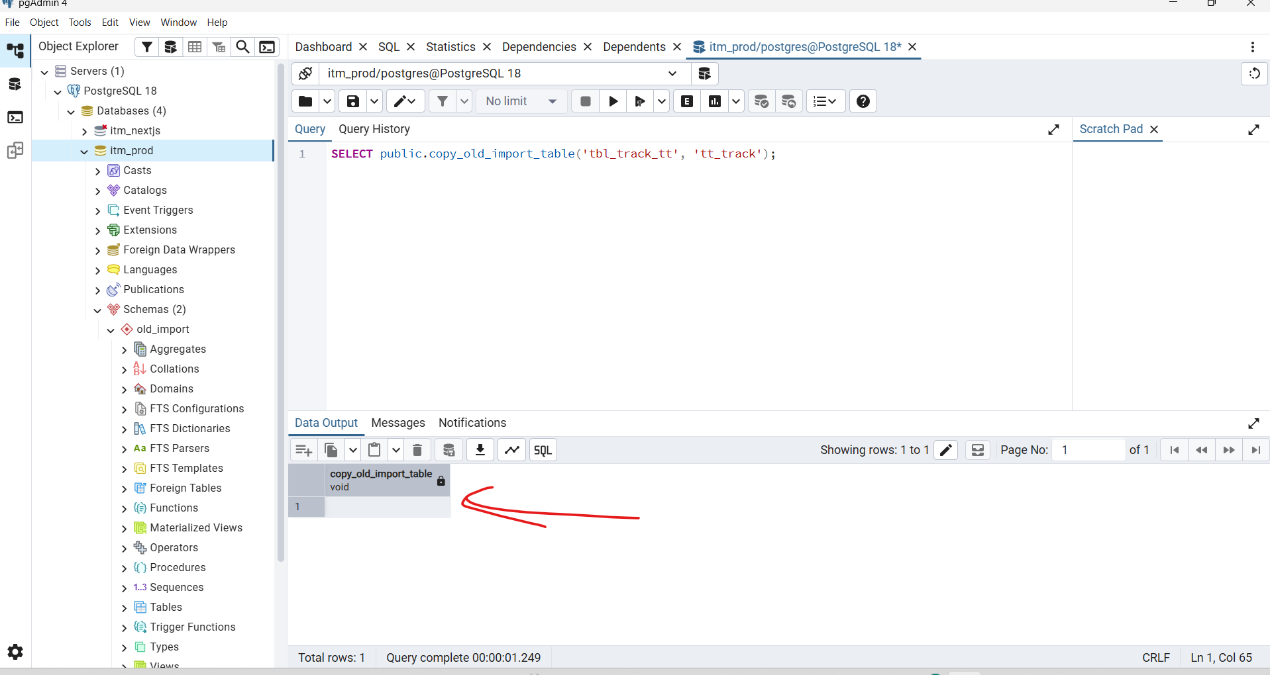

BOSS, এই query টার meaning হলো:
SELECT public.copy_old_import_table('tbl_track_tt', 'tt_track');
এটা PostgreSQL function call করছে।
মানে:
public.copy_old_import_table নামে একটা function আছে public schema-তে।
এই function-কে ২টা value পাঠানো হচ্ছে:
'tbl_track_tt'
'tt_track'
Function নাম দেখে বোঝা যাচ্ছে, এটা সম্ভবত:
old_import schema/table থেকে data copy করে target table এ insert/update করছে
মানে likely:
Source old table: tbl_track_tt
Target new table: tt_track
তোমার screenshot-এ output এ void দেখাচ্ছে কারণ function কোনো data return করে না। শুধু কাজটা execute করে। তাই result grid-এ actual row/data আসেনি।
এটা error না।
Query complete মানে function successfully run হয়েছে।
এই function আসলে ভিতরে কী করছে দেখতে চাইলে run করো:
SELECT pg_get_functiondef(p.oid)
FROM pg_proc p
JOIN pg_namespace n ON n.oid = p.pronamespace
WHERE n.nspname = 'public'
AND p.proname = 'copy_old_import_table';
আর data copy হয়েছে কিনা check করতে:
SELECT COUNT(*) FROM old_import.tbl_track_tt;
SELECT COUNT(*) FROM public.tt_track;
সহজ ভাষায়: এই query data show করার জন্য না, বরং একটা custom function চালানোর জন্য।

All query done with check. now next step
Thought for 4s
Great, BOSS ✅
Now data copy/import part is done. Next step is final database cleanup + backend/frontend test.
1. Fix all sequences
Run this in pgAdmin Query Tool:
SELECT setval(pg_get_serial_sequence('employee_personal_info', 'id'), COALESCE((SELECT MAX(id) FROM public.employee_personal_info), 1), true);
SELECT setval(pg_get_serial_sequence('employee_office_info', 'id'), COALESCE((SELECT MAX(id) FROM public.employee_office_info), 1), true);
SELECT setval(pg_get_serial_sequence('inventory_categories', 'id'), COALESCE((SELECT MAX(id) FROM public.inventory_categories), 1), true);
SELECT setval(pg_get_serial_sequence('fault_types', 'id'), COALESCE((SELECT MAX(id) FROM public.fault_types), 1), true);
SELECT setval(pg_get_serial_sequence('it_equipment', 'id'), COALESCE((SELECT MAX(id) FROM public.it_equipment), 1), true);
SELECT setval(pg_get_serial_sequence('stack_inventory', 'id'), COALESCE((SELECT MAX(id) FROM public.stack_inventory), 1), true);
SELECT setval(pg_get_serial_sequence('equipment_status_history', 'id'), COALESCE((SELECT MAX(id) FROM public.equipment_status_history), 1), true);
SELECT setval(pg_get_serial_sequence('device_claims', 'id'), COALESCE((SELECT MAX(id) FROM public.device_claims), 1), true);
SELECT setval(pg_get_serial_sequence('damage_inventory', 'id'), COALESCE((SELECT MAX(id) FROM public.damage_inventory), 1), true);
SELECT setval(pg_get_serial_sequence('warranty_vendors', 'id'), COALESCE((SELECT MAX(id) FROM public.warranty_vendors), 1), true);
SELECT setval(pg_get_serial_sequence('ownership_transfers', 'id'), COALESCE((SELECT MAX(id) FROM public.ownership_transfers), 1), true);
SELECT setval(pg_get_serial_sequence('tt_track', 'id'), COALESCE((SELECT MAX(id) FROM public.tt_track), 1), true);

2. Give final permission to backend user
GRANT USAGE ON SCHEMA public TO itm_user;
GRANT SELECT, INSERT, UPDATE, DELETE
ON ALL TABLES IN SCHEMA public
TO itm_user;
GRANT USAGE, SELECT, UPDATE
ON ALL SEQUENCES IN SCHEMA public
TO itm_user;

3. Verify final public table counts
SELECT
(SELECT COUNT(*) FROM public.employee_personal_info) AS employee_personal_info,
(SELECT COUNT(*) FROM public.employee_office_info) AS employee_office_info,
(SELECT COUNT(*) FROM public.inventory_categories) AS inventory_categories,
(SELECT COUNT(*) FROM public.fault_types) AS fault_types,
(SELECT COUNT(*) FROM public.it_equipment) AS it_equipment,
(SELECT COUNT(*) FROM public.stack_inventory) AS stack_inventory,
(SELECT COUNT(*) FROM public.equipment_status_history) AS equipment_status_history,
(SELECT COUNT(*) FROM public.device_claims) AS device_claims,
(SELECT COUNT(*) FROM public.damage_inventory) AS damage_inventory,
(SELECT COUNT(*) FROM public.warranty_vendors) AS warranty_vendors,
(SELECT COUNT(*) FROM public.ownership_transfers) AS ownership_transfers,
(SELECT COUNT(*) FROM public.tt_track) AS tt_track;

4. Check admin login is still safe
SELECT
username,
employee_id,
full_name,
active,
user_type,
LENGTH(password_hash) AS hash_len
FROM public.users
WHERE username = 'admin';
Expected:
admin | ADMIN-001 | System Administrator | true | 1

5. Restart backend
PowerShell:
netstat -ano | findstr :8080
Kill PID if running:
taskkill /PID YOUR_PID /F
Start backend:
cd D:\ITM-Data\itm\itm\backend
go run ./cmd/server

6. Test login API
New PowerShell:
$body = @{
username = "admin"
password = "Admin@1234"
} | ConvertTo-Json
Invoke-RestMethod `
-Uri "http://localhost:8080/api/v1/auth/login" `
-Method POST `
-ContentType "application/json" `
-Body $body
Expected response should include token.

7. Restart frontend
cd D:\ITM-Data\itm\itm\frontend
npx next dev -p 5173
Open:
http://localhost:5173
Login:
admin
Admin@1234
Then check dashboard pages:
/dashboard
/dashboard/reports/assets
/dashboard/service-warranty/service-claims
/dashboard/service-warranty/warranty-claims

8. Do not delete old_import yet
Keep old_import schema for now. It is useful for comparing old vs new data.
Later, after everything is confirmed, you can remove it with:
DROP SCHEMA old_import CASCADE;
But do not run this now. Keep it until all pages are verified.

3. Verify final public table counts
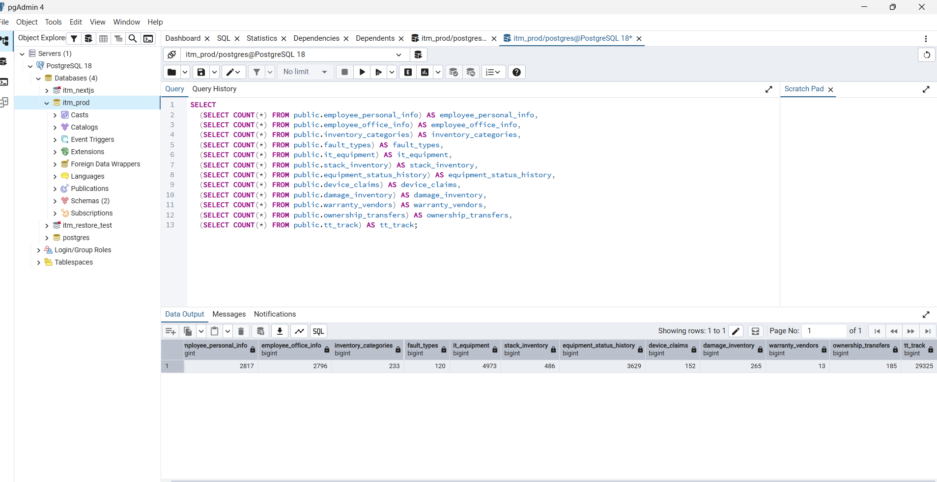

SELECT
(SELECT COUNT(*) FROM public.employee_personal_info) AS employee_personal_info,
(SELECT COUNT(*) FROM public.employee_office_info) AS employee_office_info,
(SELECT COUNT(*) FROM public.inventory_categories) AS inventory_categories,
(SELECT COUNT(*) FROM public.fault_types) AS fault_types,
(SELECT COUNT(*) FROM public.it_equipment) AS it_equipment,
(SELECT COUNT(*) FROM public.stack_inventory) AS stack_inventory,
(SELECT COUNT(*) FROM public.equipment_status_history) AS equipment_status_history,
(SELECT COUNT(*) FROM public.device_claims) AS device_claims,
(SELECT COUNT(*) FROM public.damage_inventory) AS damage_inventory,
(SELECT COUNT(*) FROM public.warranty_vendors) AS warranty_vendors,
(SELECT COUNT(*) FROM public.ownership_transfers) AS ownership_transfers,
(SELECT COUNT(*) FROM public.tt_track) AS tt_track;

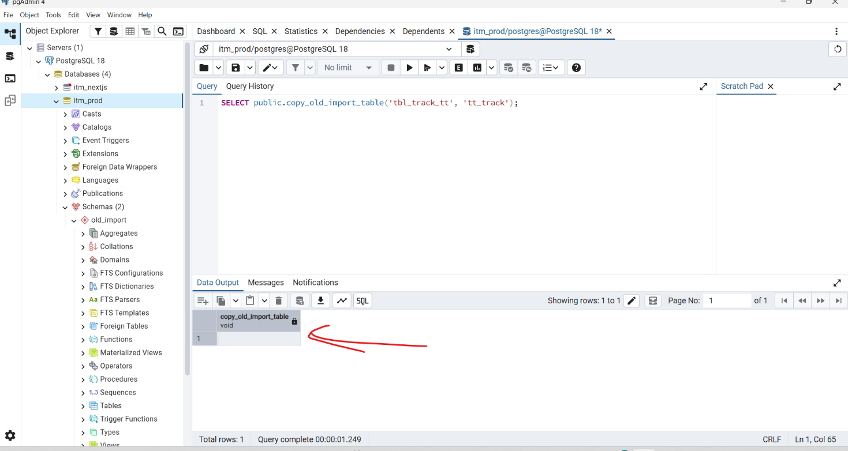

BOSS, এই query টার meaning হলো:
SELECT public.copy_old_import_table('tbl_track_tt', 'tt_track');
এটা PostgreSQL function call করছে।
মানে:
public.copy_old_import_table নামে একটা function আছে public schema-তে।
এই function-কে ২টা value পাঠানো হচ্ছে:
'tbl_track_tt'
'tt_track'
Function নাম দেখে বোঝা যাচ্ছে, এটা সম্ভবত:
old_import schema/table থেকে data copy করে target table এ insert/update করছে
মানে likely:
Source old table: tbl_track_tt
Target new table: tt_track
তোমার screenshot-এ output এ void দেখাচ্ছে কারণ function কোনো data return করে না। শুধু কাজটা execute করে। তাই result grid-এ actual row/data আসেনি।
এটা error না।
Query complete মানে function successfully run হয়েছে।
এই function আসলে ভিতরে কী করছে দেখতে চাইলে run করো:
SELECT pg_get_functiondef(p.oid)
FROM pg_proc p
JOIN pg_namespace n ON n.oid = p.pronamespace
WHERE n.nspname = 'public'
AND p.proname = 'copy_old_import_table';
আর data copy হয়েছে কিনা check করতে:
SELECT COUNT(*) FROM old_import.tbl_track_tt;
SELECT COUNT(*) FROM public.tt_track;
সহজ ভাষায়: এই query data show করার জন্য না, বরং একটা custom function চালানোর জন্য।
how to show all data inside this page for pdAdmin query Microsoft Windows [Version 10.0.26200.8655] (c) Microsoft Corporation. All rights reserved. D:\Program Files\PostgreSQL\18\pgAdmin 4\runtime>"D:\Program Files\PostgreSQL\18\pgAdmin 4\runtime\psql.exe" "host=localh ost port=5432 dbname=itm_prod user=postgres sslmode=prefer connect_timeout=10" 2>>&1 psql (18.4) WARNING: Console code page (437) differs from Windows code page (1252) 8-bit characters might not work correctly. See psql reference page "Notes for Windows users" for details. Type "help" for help. itm_prod=#
Thought for 11s
BOSS, এখন যেই query চালাইছো:
SELECT public.copy_old_import_table('tbl_track_tt', 'tt_track');
এটা data show করার query না। এটা একটা function চালাচ্ছে, আর function return type void, তাই pgAdmin শুধু void column দেখাচ্ছে।
Data দেখতে হলে table থেকে SELECT * করতে হবে।
pgAdmin Query Tool এ data show করার query
Source old table দেখতে:
SELECT *
FROM old_import.tbl_track_tt;
Target/new table দেখতে:
SELECT *
FROM public.tt_track;
Data count check করতে:
SELECT COUNT(*)
FROM old_import.tbl_track_tt;
SELECT COUNT(*)
FROM public.tt_track;
শুধু first 100 rows দেখতে:
SELECT *
FROM public.tt_track
LIMIT 100;
All data দেখতে হলে LIMIT দিবা না:
SELECT *
FROM public.tt_track;
psql command line থেকে দেখার জন্য
তোমার screen এখন এখানে আছে:
itm_prod=#
এখানে লিখো:
SELECT * FROM public.tt_track;
তারপর Enter চাপো।
Source table দেখতে:
SELECT * FROM old_import.tbl_track_tt;
Table আসলেই কোন schema তে আছে check করতে
\dt old_import.*
\dt public.*
Table structure দেখতে:
\d old_import.tbl_track_tt
\d public.tt_track
Console এ output আটকে গেলে
psql অনেক data হলে pager খুলতে পারে। আগে এটা চালাও:
\pset pager off
তারপর:
SELECT * FROM public.tt_track;
pgAdmin UI দিয়ে All Rows দেখতে
Left sidebar থেকে:
Schemas → public → Tables → tt_track
তারপর table এর উপর Right Click:
View/Edit Data → All Rows
old_import.tbl_track_tt দেখতে হলে:
Schemas → old_import → Tables → tbl_track_tt
Right Click:
View/Edit Data → All Rows
Main কথা:
copy_old_import_table(...) function শুধু copy/import কাজ করে। Data দেখতে হলে SELECT * FROM table_name; চালাতে হবে।

